| **Test Name** | | Successful Produce Graphs Charts Visualisations of Errors | | | |
| --- | --- | --- | --- | --- | --- |
| **Use Case Tested:** | | Use Case 4 – Produce Graphs Charts Visualisations of Errors | | | |
| **Test Description:** | | User wishes to run a report.  User enters a valid username for the administration authority level.  User enters a valid password that relates to the username.  User selects Submit button.  User is presented with the Enter an Error page and a variety of buttons on the menu bar | | | |
| **Pre-conditions** | | A valid user name and password exists for user with administrator authority level  Data must be available in the database | | | |
| **Post-conditions** | | Metabase will display requested report | | | |
| **Notes:** | | *Screenshots relating to test can be found after the Test Data Table* | | | |
| **Result (Pass/Fail/Warning/Incomplete)** | |  | | | |
|  | **TEST STEP** | | **EXPECTED TEST RESULTS** | P | F |
|  | User enters valid administrator username | | No error appears | P |  |
|  | User enters valid password that relates to username | | No error appears | P |  |
|  | User selects Submit button | | Enter an Error page appears | P |  |
|  |  | | Menu bar shows extra options being available to the User – Report button being one of these | P |  |
|  | User selects Report button on Menu bar | | Login screen for Metabase is presented to user | P |  |
|  | User enters username: pharmacon@gmail.com | | No error appears | P |  |
|  | User enters password: pharmac0n | | No Error appears | P |  |
|  | User selects submit | | Metabase accepts login and dashboard will appear | P |  |
|  | User selects required report | | Report visualisation appears | P |  |

|  |  |  |  |  |  |
| --- | --- | --- | --- | --- | --- |
| **Test Data Table** | | | | | |
|  | **1** | **2** | **3** | **4** | **5** |
| Valid Username: PET | admin@test.com |  |  |  |  |
| Valid Password: PET | super123 |  |  |  |  |
| Valid Username: Metabase | pharmacon@gmail.com |  |  |  |  |
| Valid Password: Metabase | pharmac0n |  |  |  |  |
|  |  |  |  |  |  |
|  |  |  |  |  |  |
|  |  |  |  |  |  |
|  |  |  |  |  |  |
|  |  |  |  |  |  |

SCREENSHOTS RELATING TO TEST

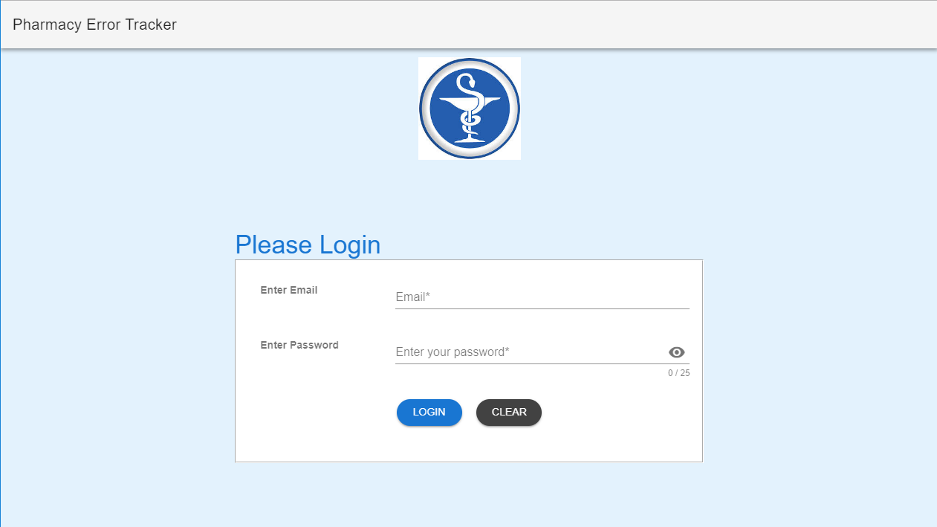

Picture of the initial login page the user is given on connection to the Pharmacy Error Tracker (PET) web application

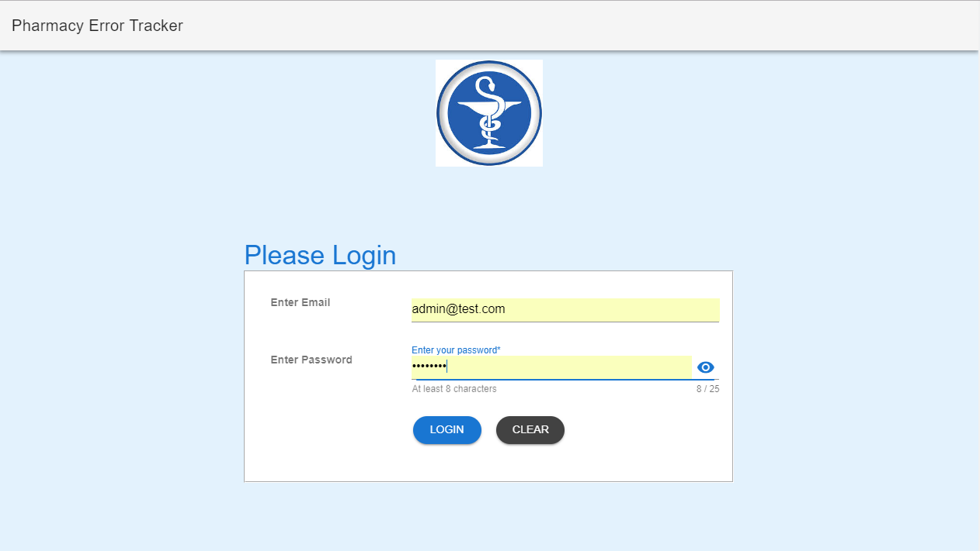

Picture of the initial login page the user is given on connection to the Pharmacy Error Tracker (PET) web application with the username and password entered.

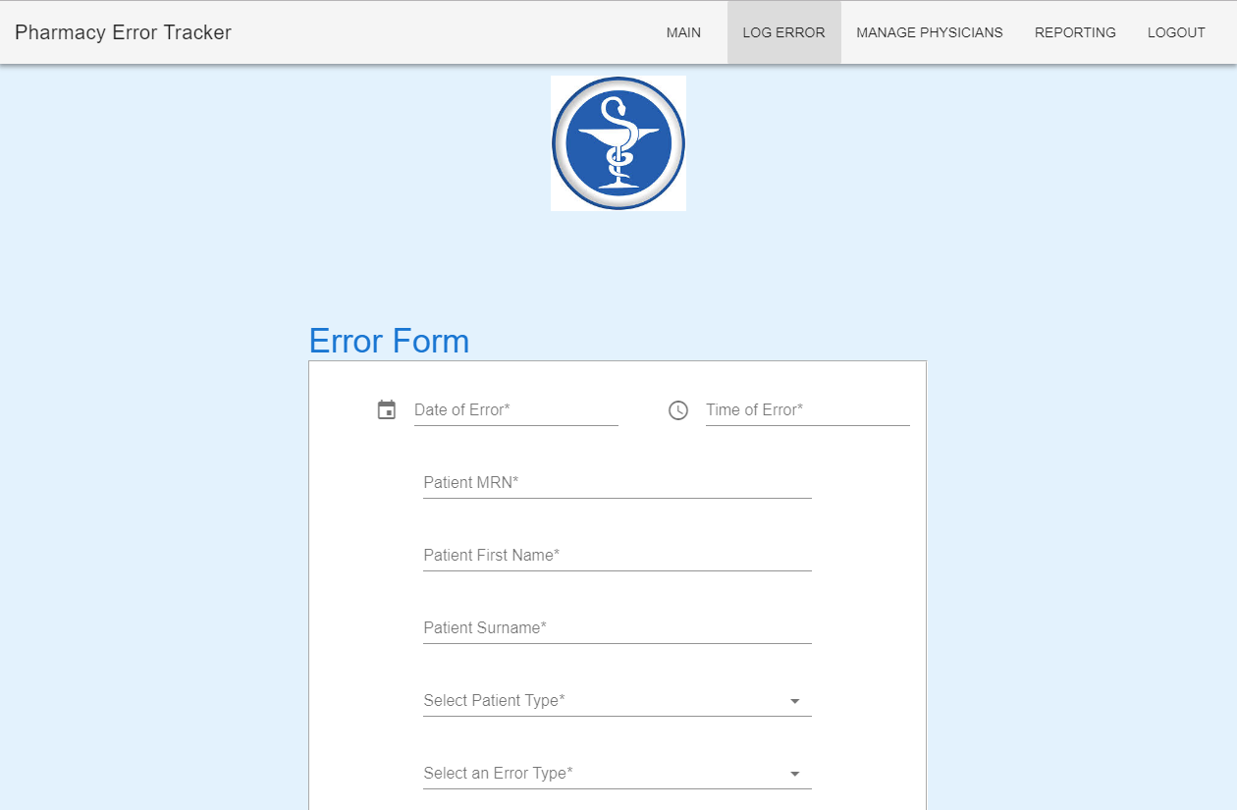

Picture of the Error form being displayed after successful login, the extra buttons for the administrator are displayed at the top of the screen also.